

PROJECT REPORT

ATM MANAGEMENT SYSTEM

        - Project title : ATM Management System
        - Course title : Programming in Python
        - Course code : CSE 1021
        - Course type : Flipped course
        - Professor : Dr. Kannan Shanmugam
        - Slot : B11+E11+B12+E12+B12+C14
        - Submitted by : Vikashini A
        - Registration number : 26MIP10065
        - Submission date : 30/09/2026
INTRODUCTION :
The ATM Management System is a simple menu-driven Python application that simulates basic ATM operations. The program authenticates the user using a PIN and, after successful authentication, provides options to check the current balance, deposit money, withdraw money, or exit. The application starts with a balance of ■10,000 and updates the balance after valid transactions.
PROBLEM STATEMENT :
A basic ATM system must authenticate a user, accept a transaction choice, validate the requested amount, update the account balance, and provide clear feedback. This project demonstrates these operations through a simple command-line Python program.
PROJECT OBJECTIVES :
- Develop a simple ATM simulation using Python.
- Implement PIN-based authentication.
- Allow balance checking.
- Implement deposits and withdrawals.
- Validate transaction amounts and available balance.
- Demonstrate functions, conditions, loops, input handling, and variable updates.
FUNCTIONAL REQUIREMENTS :
- User Authentication: Accept a PIN and compare it with the predefined PIN.
- ATM Menu: Provide Check Balance, Deposit Money, Withdraw Money, and Exit options.
- Balance Management: Start with ■10,000 and update the balance after valid transactions.
- Deposit Processing: Accept only amounts greater than zero.
- Withdrawal Processing: Reject invalid amounts and withdrawals exceeding the available balance.
NON-FUNCTIONAL REQUIREMENTS :
- Usability: Simple menu and clear messages.
- Reliability: PIN and transaction validation.
- Maintainability: Separate functions for core operations.
- Resource Efficiency: Uses basic Python functionality without external libraries.
SYSTEM ARCHITECTURE :
- Presentation Layer – menu, prompts, and messages.
- Authentication Layer – PIN comparison.
- Transaction Layer – balance, deposit, and withdrawal functions.
- Balance Data – current balance variable.
- Control Layer – while-loop menu control.
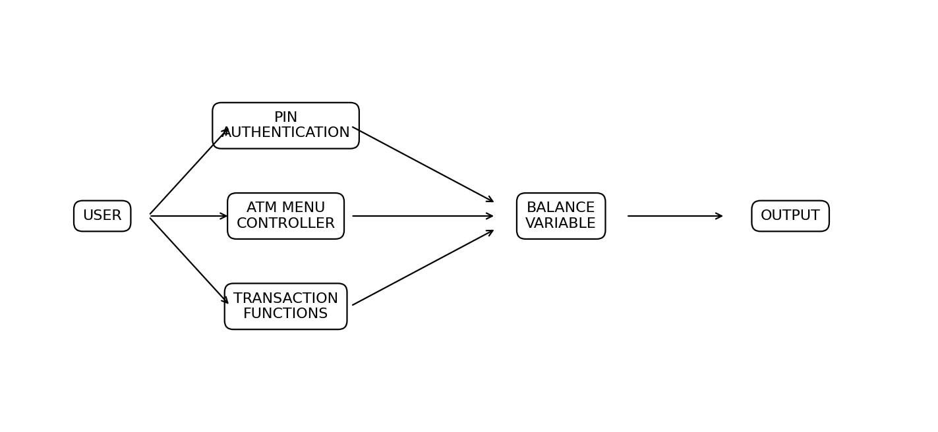
DESIGN DIAGRAMS :
- ATM Workflow
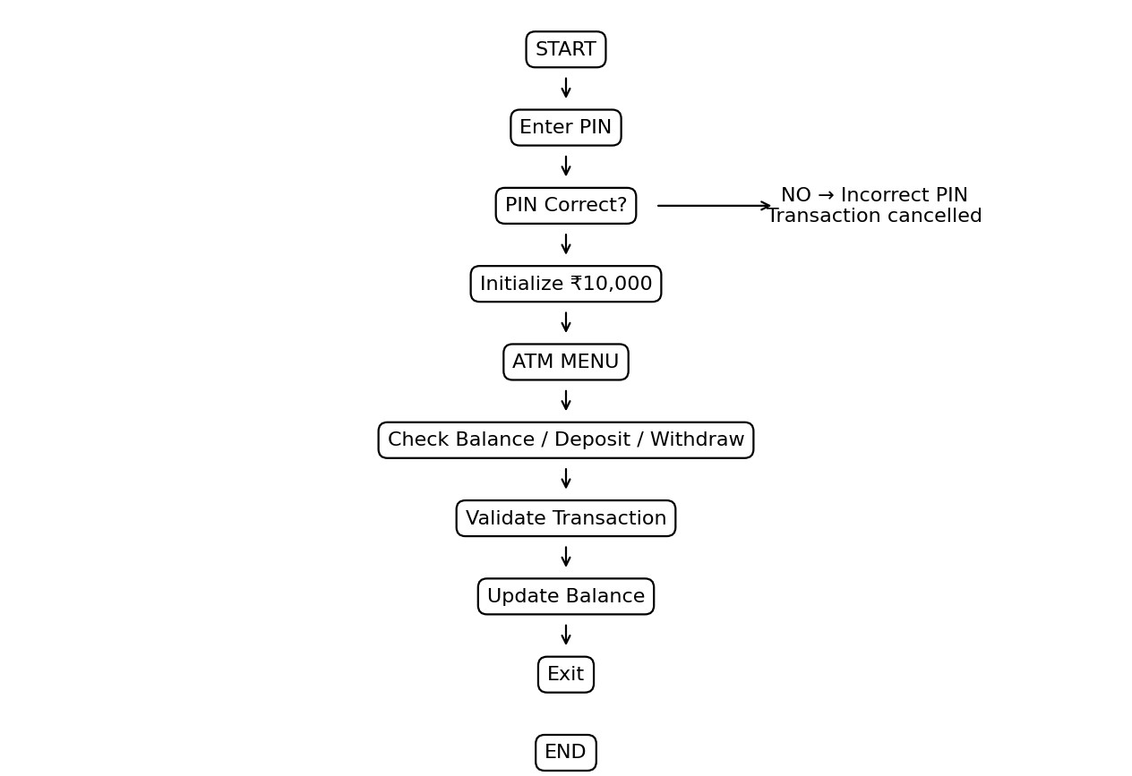
- Data Flow: User Input → PIN Authentication → ATM Menu → Transaction Function → Balance Update → Output.
DESIGN DECISIONS & RATIONALE :
- Programming Language: Python – simple syntax suitable for programming fundamentals.
- Function-Based Design – separates core operations for easier understanding and maintenance.
- Menu-Driven Interface – provides clear numbered choices.
- Conditional Validation – prevents invalid amounts and insufficient-balance withdrawals.
- Loop-Based Operation – supports multiple transactions in one authenticated session.
IMPLEMENTATION DETAILS :
- Language: Python 3
- Development Environment: Python IDLE / Visual Studio Code / Terminal
- Source File: ____________________.py
- Initial Balance: ■10,000
- Primary control flow: while True menu loop
FUNCTION IMPLEMENTATION :
- check_balance(balance): Displays the current balance.
- deposit_money(balance): Reads a deposit amount, validates it, updates the balance, and returns the updated balance.
- withdraw_money(balance): Validates the withdrawal and available balance, updates the balance, and returns it.
- Main Program: Handles PIN authentication, menu control, and exit.
DATA STRUCTURE :
The project uses a numeric variable named balance to store the current account balance. The deposit and withdrawal functions receive the current balance, perform the required calculation, and return the updated balance.
ALGORITHM :
- Start the program.
- Display the ATM welcome message.
- Set the PIN to 1234.
- Ask the user to enter the PIN.
- If the PIN is incorrect, display an error and cancel the transaction.
- If correct, initialize balance to ■10,000.
- Display the ATM menu and read the choice.
- Process balance check, deposit, withdrawal, or exit.
- Repeat the menu until Exit is selected.
TESTING APPROACH :
- Correct PIN and incorrect PIN.
- Valid and invalid deposit amounts.
- Valid, invalid, and insufficient-balance withdrawals.
- Balance updates after transactions.
- Invalid menu choices.
- Exit operation.
SAMPLE OUTPUT :
================================
WELCOME TO ATM
================================
Enter your PIN: 1234
---------- ATM MENU ----------
  - Check Balance
  - Deposit Money
  - Withdraw Money
  - Exit
------------------------------
Enter your choice: 1
Your current balance is: ■ 10000
CHALLENGES FACED :
- Handling PIN authentication.
- Validating positive transaction amounts.
- Preventing withdrawals above the available balance.
- Maintaining the updated balance across repeated menu operations.
- Displaying clear feedback for invalid choices.
OUTPUT :
The program produces authentication feedback, balance information, successful deposit and withdrawal messages, insufficient-balance warnings, invalid-choice messages, and an exit message.
LEARNINGS AND KEY TAKEAWAYS :
- Python functions and return values.
- Conditional statements.
- While-loop based menu control.
- User input and output.
- Updating variables through transactions.
- Basic validation for financial operations.
FUTURE ENHANCEMENTS :
- Multiple user accounts.
- Transaction history and mini statements.
- PIN change and multiple-attempt lockout.
- Database-based account storage.
- Graphical user interface.
- Improved handling of non-numeric input.
- Additional ATM operations.
CONCLUSION :
The ATM Management System demonstrates how Python programming concepts can be combined to simulate essential ATM operations. The project uses functions, conditional statements, loops, user input, and variable updates to implement PIN authentication, balance checking, deposits, withdrawals, and program termination. The simple design provides a foundation for future account management, secure storage, transaction history, and graphical-interface features.
PROJECT SOURCE CODE :
The implementation contains check_balance(), deposit_money(), withdraw_money(), PIN authentication, the ATM menu, and balance management logic.
REFERENCES :
- Python Software Foundation – Python Documentation.
- Python documentation for functions, input/output, conditional statements, and while loops.

